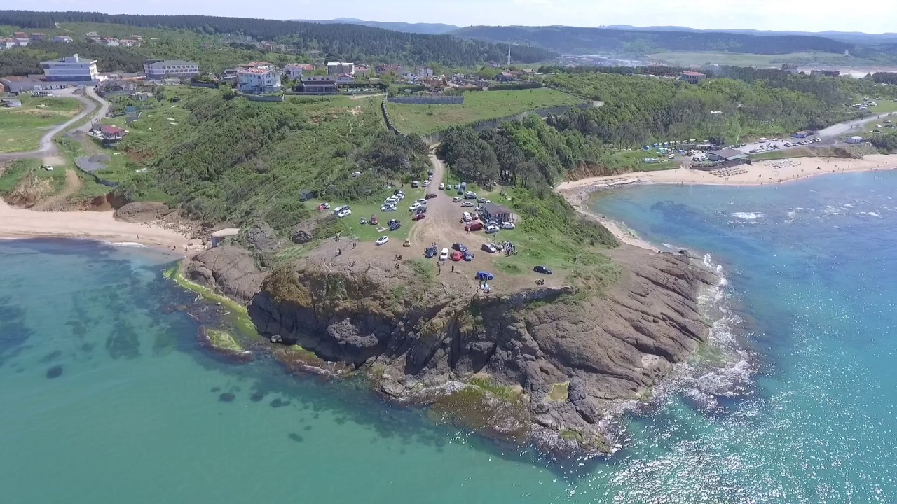
Walking from Poyraz to Riva via Anadolu Feneri this Sunday
There will be a hiking activity in rural Istanbul within the course TRM 48R.01 Sustainability from Environmental and Social Perspectives on the 21st of October this Sunday. Students and academics from the Department of Tourism Administration are also invited. As we have limited place you are kindly asked to contact Dr. Akgün İlhan (akgunilhan@gmail.com) for confirmation until this Saturday, 20th of October.
More info below:
Sunday, October 21st, 2018
From Poyraz to Riva via Anadolu Feneri
3 historic coastal villages, early autumn, wonderful views, a stretch of path-cutting and a stretch of jungle avoiding (we hope).
The hike: quite hilly; the path-cutting part is likely to be tough (clifftop scrub on a downhill slope for about 250m); some of us will be armed with gloves and secateurs; it’s an exceptionally scenic hike.
Difficulties & challenges: The path-cutting might not work; if it doesn’t we’ll have to backtrack and take the stretch of road as we used to.
Weather forecast (as of today): 20 degrees, 13 degrees after sunset. Dry. Cloudy. I’ll update the weather forecast on the Facebook event page the day before the hike.
How will we meet?
We’ll catch the 135 bus which leaves Kavacık IETT bus station (Kavacık Aktarma) at 09:45am (or you can catch the same bus around 10am from Beykoz merkez). The bus can leave a minute or 2 early. if you’re coming from the European side, the easiest way to the Kavacık bus station is to take any bus across the 2nd bridge from Levent 1 (it’s the last stop out of 3 adjacent stops on the east side of the road after exiting Levent 1 metro) then walk to Kavacık from the Kavacık crossroads. Allow 15 mins. If you’re running late or just if you prefer, you can catch the same bus from the stop which is just south of the Kavacık crossroads (Kavacık Sapağı) though it’s an unpleasant place to wait) arriving 2 mins after it leaves Kavacık Aktarma. To find this stop: get off any bus coming over the 2nd bridge, alight at the first stop after the bridge, climb the stairs you see next to the stop. At the top of the stairs, turn right and you’ll see the stop. Or to get Kavacık Aktarma, turn left at the top of the same stairs, stay on the same side of the road, cross over the highway, and keep walking up to Kavacık. The advantage of catching the bus in Kavacık is that you’re sure of getting a seat. If you miss this bus, you miss the hike, as the next bus is more than 2 hours later. At the end of the hike, there are buses and dolmuş from Riva. For detailed info on bus times and routes check http://www.iett.istanbul.
Clothing etc: Be ready for jungle and for coolness after dark. There will be little mud. Boots will be better than shoes. Good walking shoes will work though. Long trousers are essential. If you have secateurs please bring them, if you don’t, that’s fine.
Distance & hilliness: About 14kms. Fairly hilly
Duration (including breaks): About 8-9 hours

