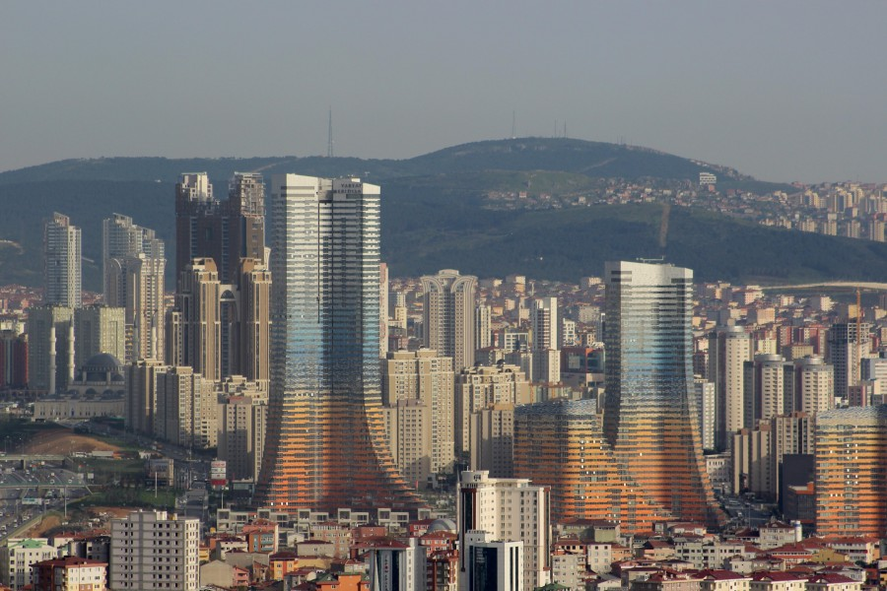

Walking the Route of Unsustainability: From Yenisahra to Ataṣehir with Sinan Logie

This Saturday on the 6th of October 2018 there will be a field trip within the course TRM 48R.01 Sustainability from Environmental and Social Perspectives given by Dr. Akgün İlhan. This excursion is primarily designed for students taking this course to see unsustainable land use practices in urban areas in Istanbul. However, there is a room for a limited number of interested individuals (both students and academics) from the Department of Tourism Administration Boğaziçi University in case there is a demand (Please see contact information below). The leader of the excursion will be the architect Sinan Logie from Bilgi University.

The field trip will have the following steps:

- Meeting at 10.30am at Kadıköy subway entrance, next to the Beṣiktaṣ pier.
- Walking form south towards north, in Istanbul’s urban areas along the Marmara Sea, offers the opportunity to read the city’s evolution, as the age rings of a tree. The drift will start in Yenisahra, along the E5 urban highway, trace of the 1970’s urban policies.
- After passing by some squatter settlements, from the 1980’s, the walk will end in Ataṣehir, along the TEM highway from the 1990’s. Ataṣehir gives the students the opportunity to see and discuss about the recent neo-liberal developments of the megapolis.

Sinan Logie Biography

In 1998, after his Architecture Studies at Institut Superieur d’Architecture Victor Horta in Brussels, Sinan started his collaboration with one of Belgium’s most progressive architecture office: L’Escaut. Since 2005, Sinan has developed his personal architectural and artistic work through various projects in Belgium and Turkey. He is currently working with Oktem Aykut Gallery in Istanbul. His work has been exhibited and published in Europe, USA and Turkey. He is currently leading his researches and teaching architectural design studio courses at Istanbul Bilgi University. Sinan is the co-author, with Yoann Morvan of the recently published book ‘’Istanbul 2023’’ analyzing the urban spread of Istanbul. In 2015 Sinan co-founded with Yasar Adanalı, the Center for Spatial Justice, Beyond Istanbul. An independent urban research institute, focusing on urban justice issues.
Feel free to contact Akgün İlhan from this e-mail akgunilhan@gmail.com until 5th of October 2018 if you are interested in joining this trip.
Note: Please do not forget to check weather in advance and wear accordinly (proper walking shoes and warm clothes if necessary).

